**Android Application that uses GUI components, Font and Colours**

**Procedure:**

**Creating a New project:**

* Open Android Studio and then click on **File -> New -> New project.**

[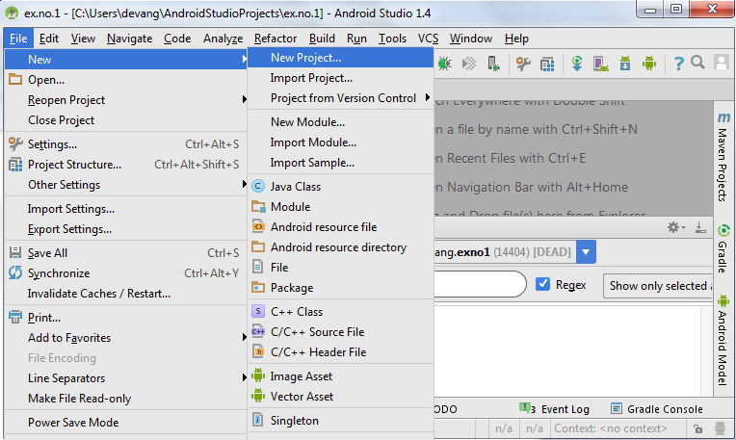](https://codingconnect.net/wp-content/uploads/2016/02/new-project.png)

* Then type the Application name as “**ex.no.1″** and click **Next.**

[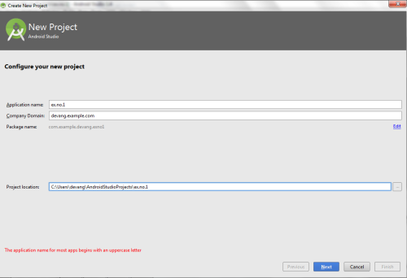](https://codingconnect.net/wp-content/uploads/2016/02/application-name-e1456070044915.png)

* Then select the **Minimum SDK** as shown below and click **Next**.

[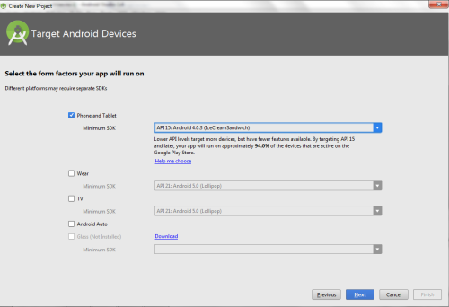](https://codingconnect.net/wp-content/uploads/2016/02/minimum-sdk-e1456069978476.png)

* Then select the **Empty Activity** and click **Next.**

[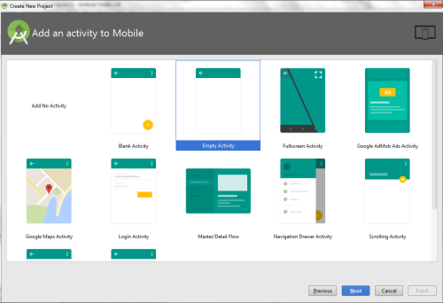](https://codingconnect.net/wp-content/uploads/2016/02/empty-activity-e1456120797105.png)

* Finally click F**inish**.

[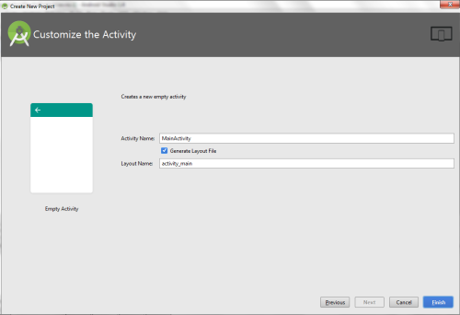](https://codingconnect.net/wp-content/uploads/2016/02/finish-e1456121463611.png)

* It will take some time to build and load the project.
* After completion it will look as given below.

[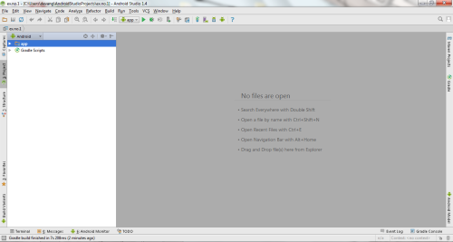](https://codingconnect.net/wp-content/uploads/2016/02/new-e1456122290334.png)

**Designing layout for the Android Application:**

* Click on **app -> res -> layout -> activity_main.xml.**

[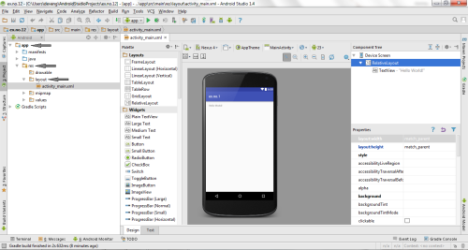](https://codingconnect.net/wp-content/uploads/2016/02/activity_main-e1456123429693.png)

* Now click on **Text** as shown below.

[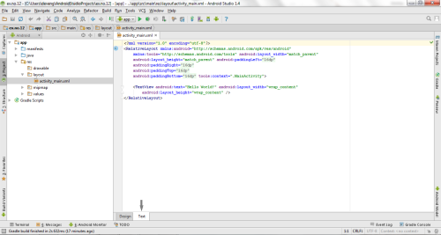](https://codingconnect.net/wp-content/uploads/2016/02/text-e1456124006902.png)

Experiment-1

**MainActivity.java**

package com.example.test1;  
  
import androidx.appcompat.app.AppCompatActivity;  
  
import android.graphics.Color;  
import android.os.Bundle;  
import android.view.View;  
import android.widget.Button;  
import android.widget.Switch;  
import android.widget.TextView;  
  
public class MainActivity extends AppCompatActivity {  
  
 TextView t;  
 Button btn1,btn2;  
 int font=30;  
 int ch = 1;  
  
 @Override  
 protected void onCreate(Bundle savedInstanceState) {  
 super.onCreate(savedInstanceState);  
 setContentView(R.layout.*activity_main*);  
 t = findViewById(R.id.*textView*);  
 btn1 = findViewById(R.id.*button*);  
 btn2 = findViewById(R.id.*button2*);  
  
 btn1.setOnClickListener(new View.OnClickListener() {  
 @Override  
 public void onClick(View view) {  
 t.setTextSize(font);  
 font = font + 5;  
 if (font == 60){  
 font = 30;  
 }  
 }  
 });  
  
 btn2.setOnClickListener(new View.OnClickListener() {  
 @Override  
 public void onClick(View view) {  
 switch (ch){  
 case 1: t.setTextColor(Color.*BLACK*);  
 break;  
 case 2: t.setTextColor(Color.*BLUE*);  
 break;  
 case 3: t.setTextColor(Color.*GREEN*);  
 break;  
 case 4: t.setTextColor(Color.*RED*);  
 break;  
 case 5: t.setTextColor(Color.*MAGENTA*);  
 break;  
 case 6: t.setTextColor(Color. *YELLOW*);  
 break;  
 }  
 ch++;  
 if (ch == 6)  
 ch = 1;  
 }  
 });  
 }  
}

**activity_main.xml**

<?xml version="1.0" encoding="utf-8"?>  
<LinearLayout xmlns:android="http://schemas.android.com/apk/res/android"  
 xmlns:app="http://schemas.android.com/apk/res-auto"  
 xmlns:tools="http://schemas.android.com/tools"  
 android:layout_width="match_parent"  
 android:orientation="vertical"  
 android:layout_margin="20dp"  
 android:layout_height="match_parent"  
 tools:context=".MainActivity">  
  
 <TextView  
 android:id="@+id/textView"  
 android:layout_width="match_parent"  
 android:layout_height="wrap_content"  
 android:layout_marginTop="50dp"  
 android:textSize="30dp"  
 android:gravity="center"  
 android:text="Hello World!" />  
  
 <Button  
 android:id="@+id/button"  
 android:layout_width="match_parent"  
 android:layout_height="wrap_content"  
 android:text="Change the text size" />  
  
 <Button  
 android:id="@+id/button2"  
 android:layout_width="match_parent"  
 android:layout_height="wrap_content"  
 android:text="Change the text colour" />  
</LinearLayout>

**Output-**

